**DAILY ONLINE ACTIVITIES SUMMARY**

|  |  |  |  |  |  |  |  |
| --- | --- | --- | --- | --- | --- | --- | --- |
| **Date:** | **14/06/2020** | | | | **Name:** | **Amrutha G** | |
| **Sem & Sec** | **4TH&A** | | | | **USN:** | **4AL18CS006** | |
| **Online Test Summary** | | | | | | | |
| **Subject** | | **----** | | | | | |
| **Max. Marks** | | **--** | | **Score** | | **--** | |
| **Certification Course Summary** | | | | | | | |
| **Course** | **Introduction of ethical hacking** | | | | | | |
| **Certificate Provider** | | | **GREAT LEARNING** | **Duration** | | | **5 HOURS** |
| **Coding Challenges** | | | | | | | |
| **Problem Statement 1: Write a C program to remove specific characters in the String.** | | | | | | | |
| **Status: executed** | | | | | | | |
| **Uploaded the report in Github** | | | | **YES** | | | |
| **If yes Repository name** | | | | **https://github.com/AMRUTHAGANESH**  **https://github.com/AMRUTHAGANESH/lockdown-certification_course** | | | |
| **Uploaded the report in slack** | | | | **YES** | | | |

**Online Test Summary:** NOT CONDUCTED

**Online Certification course:**

Name of the course : Introduction to ethical hacking

Duration: 5 hours

Certificate provider: great learning

Snap shot:

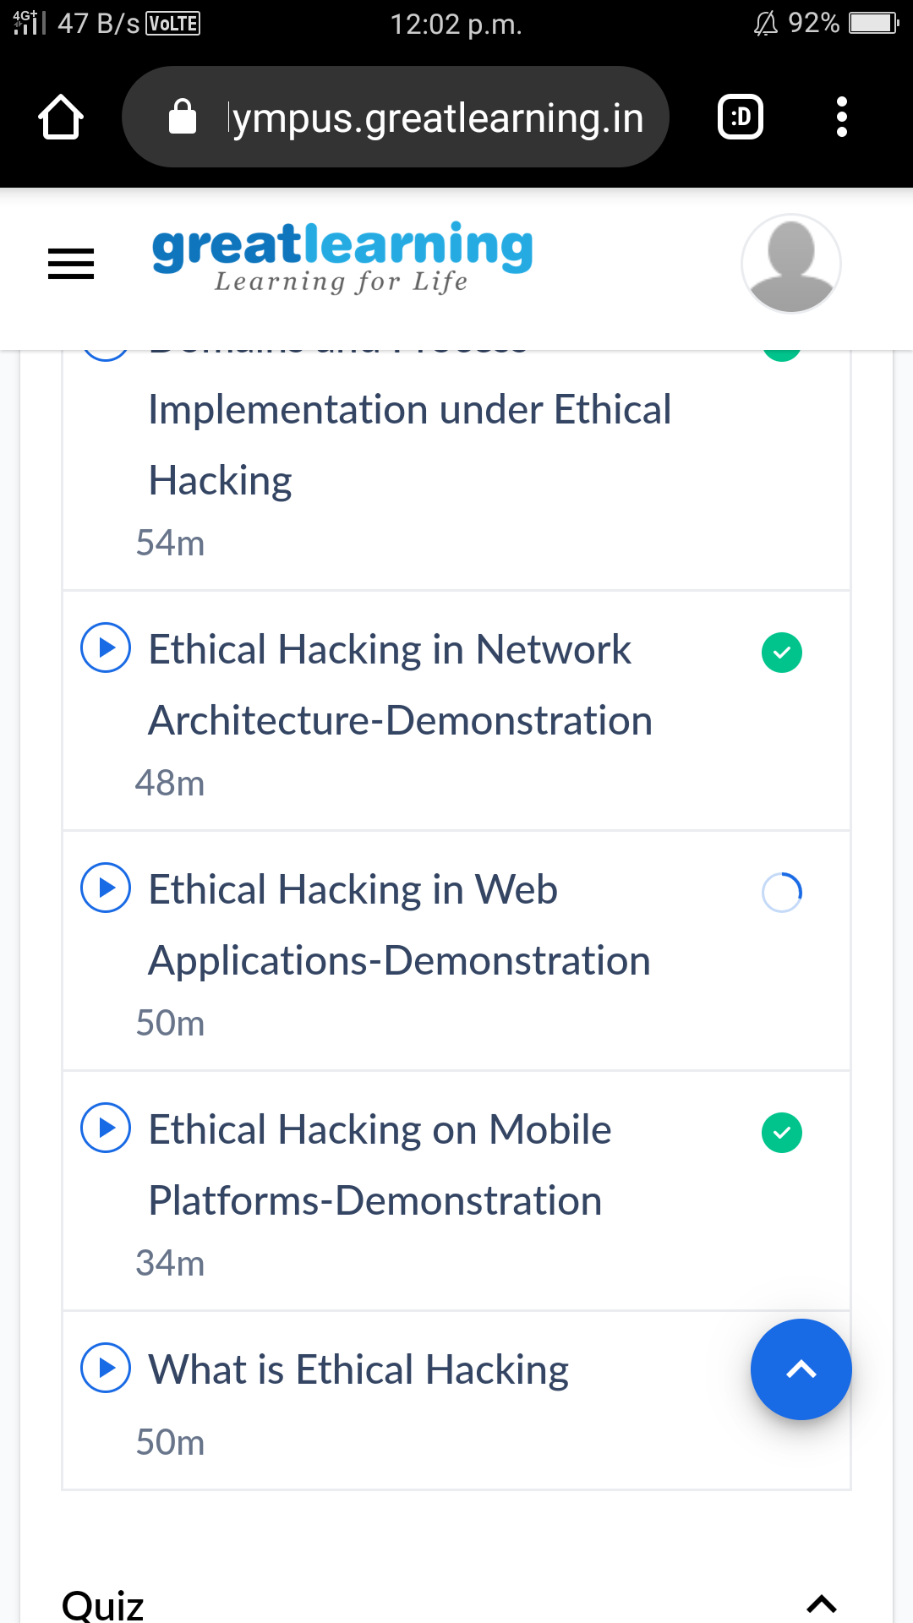

In todays session I have successfully completed my course

Online Coding summary:

1. **Write a C program to remove specific characters in the String.**

